This lab is in two parts (A & B). The code for each part is appended at the end. For each of Part A and Part B, do the following:

1. Implement the code in Python.
2. Insert screenshots of all visualizations in the relevant sections below.
3. Answer the following questions, underneath the visualization for the relevant section below:
   1. Describe the dataset.
   2. Explain the meaning of the result, by referencing the visualization.
   3. Draw all the valid conclusions that you can from the visualizations, and justify them with an explanation.

**Part A:**

**Description of the Dataset:**

The dataset used in this visualization involves a contingency table that cross-tabulates residence types (Urban, Suburban, Rural) with transportation mode preferences (Car, Public Transit, Bicycle). Each cell of the original table likely contains the count or frequency of individuals from a certain residence type who prefer a specific transportation mode. The analysis technique employed is Correspondence Analysis (CA), a multivariate statistical method that explores relationships between categorical variables in a low-dimensional space.

**Explanation of the Result (Referencing the Visualization):**

This visualization is a Correspondence Analysis (CA) biplot, which graphically represents the relationship between residence types (blue dots) and transportation modes (red dots). The proximity of two points indicates the strength of the association between them. Distances between different groups (residences and transportation modes) reflect similarity in patterns of preferences or usage. The axes (dimensions) are derived from eigenvectors of the correspondence matrix and account for the majority of the variation in the data.

**Valid Conclusions and Justifications:**

The correspondence analysis demonstrates distinct differences in transportation preferences based on residence type. Urban residents show a strong association with public transit, while rural residents have a preference for bicycles. Suburban residents exhibit no strong preference, as they are positioned centrally among all transportation modes. Car usage is least associated with urban areas, suggesting it is more prevalent among suburban or rural residents. Furthermore, the positioning of public transit and car usage at opposite ends of the plot indicates that these modes are preferred by different communities.

**Part B:**

**Dataset Description:**

This dataset is a contingency table showing the preferences of different age groups (Young, Middle-aged, Senior) for various beverages (Coffee, Tea, Juice). The values reflect the number of individuals in each group who prefer each beverage. Analysis was performed using Correspondence Analysis (CA) to visualize associations between categories.

**Result Explanation (Referencing the Visualization):**

The Correspondence Analysis biplot illustrates relationships between age groups (blue vectors) and beverages (red dots). Proximity and direction indicate preference strength. Axes represent significant dimensions explaining variation in preferences.

**Valid Conclusions:**

The visualization shows distinct beverage preferences by age group: Young individuals prefer coffee, seniors prefer juice, and middle-aged individuals prefer tea. Coffee and juice are opposite on the plot, suggesting inverse preferences. These patterns indicate systematic variations in beverage choices by age.

Part A Code:

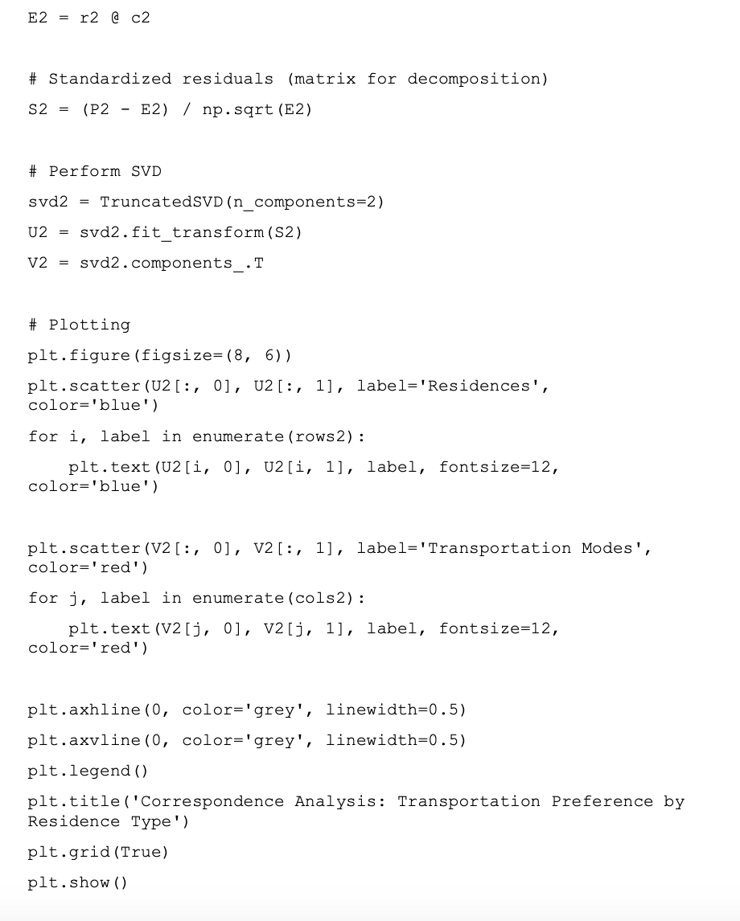

Part B Code:

